**Camera Annotation**

**User Guide**

**Table of contents**

Introduction 2

Each user will be able to: 2

Compatibility 2

Help………………. 2

Installation 2

Permissions 3

Details of button fields provided in application 5

Storage path: 7

# Introduction

Camera annotation is a mobile application which allows user to do annotations over a live camera stream and can record annotations along with video for future reference with the option for capture the screen(screenshot) whenever required.

# Each user will be able to:

Use camera annotations over a live camera as and when it is streamed.

* Take the Screen recording with the default camera.
* User can take notes over the stream with Text or pen live.
* Erase all widgets to clear all annotations taken in a shot.
* Adding the normal text field to take notes.
* Record the whole screen including annotation and free handwriting.
* Capture the screen(screenshot), whenever required.
* Clear all widgets and texts in one tap with the help of erase button.

# Compatibility

Camera Annotation is android application, this can only support android phones.

# Help

Any questions, concerns, or issues regarding the app may be resolved by contacting the Camera Annotation support team. Users may contact our support team by phone or direct email

• [bindu.kr@ltts.com](mailto:bindu.kr@ltts.com)

• 9740540728

# Installation

For Android Devices:

Search “Camera Annotation” in the Google Play Store. Install the application.

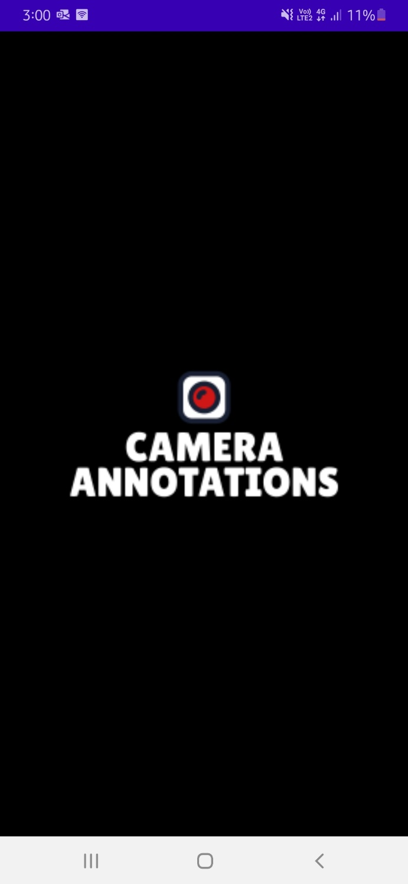

# Permissions

Soon after installing the application user should give the permission to :

1.Camera

2.Microphone

3.Storage

If user didn’t give permission, application cannot be able to access the hardware camera, microphone and external storage.

If user deny the permission for the first time, then user can manually give permission by following steps:

1.Settings

2.App permission

3.Select the application and give the permissions needed

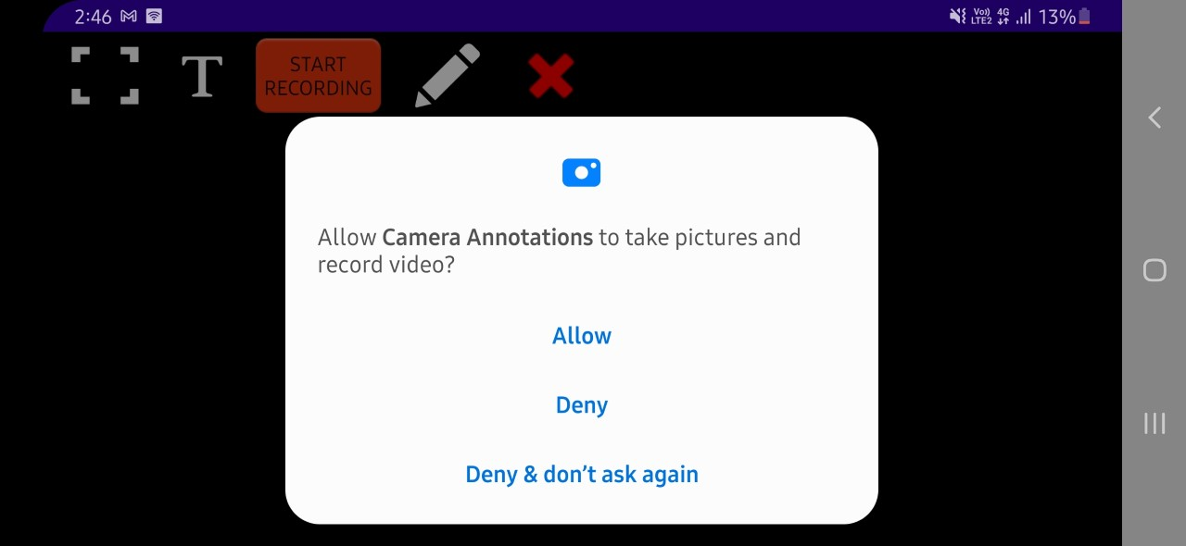

**­**

**­­**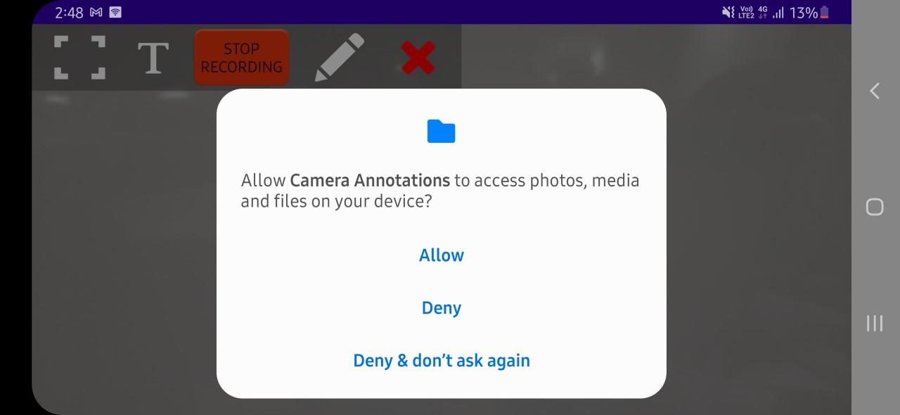

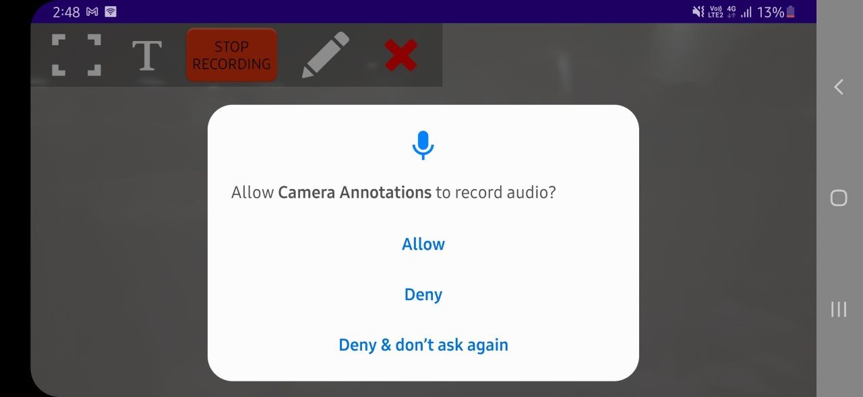

# Details of button fields provided in application

5

2

3

4

1

1. Screenshot
2. Text
3. Start and stop recording (Toggle button)
4. Pen tool
5. Clear/Erase

1.**Screenshot**: On clicking screenshot button user can be able to capture the complete screen

2.**Text**: On clicking the text button user can be able to add text on the camera screen

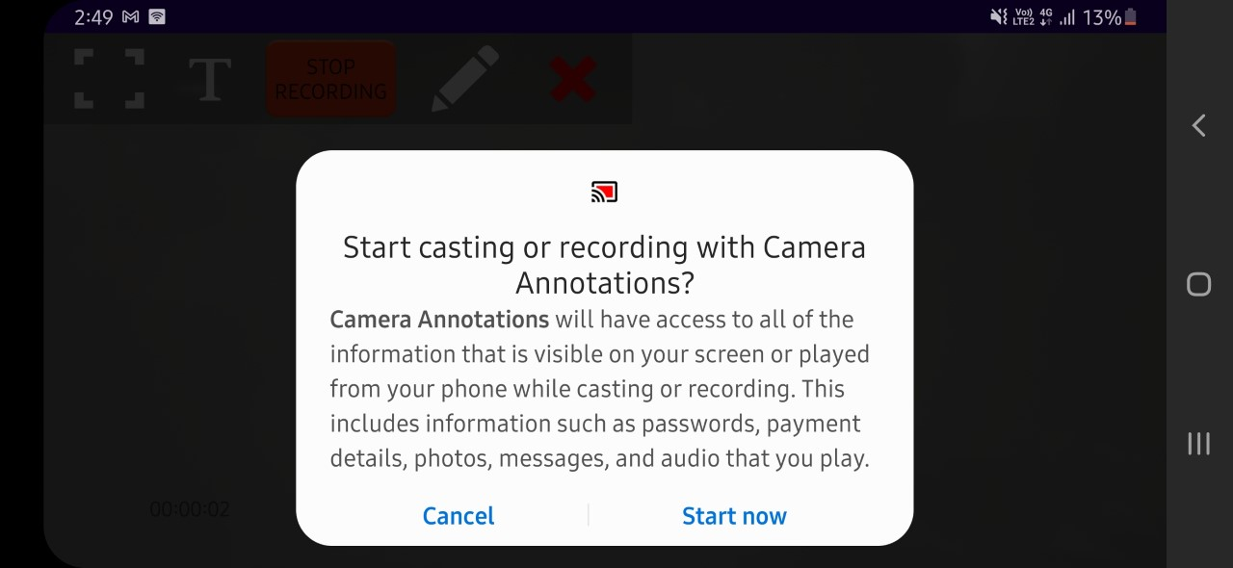

3.**Start** **Recording**: In order to save all annotation which is done over the camera preview screen user can record the complete screen including annotation that has been done on the screen

4.**Pen** **tool**: For the free handwriting user can use the pen to write anything on the screen

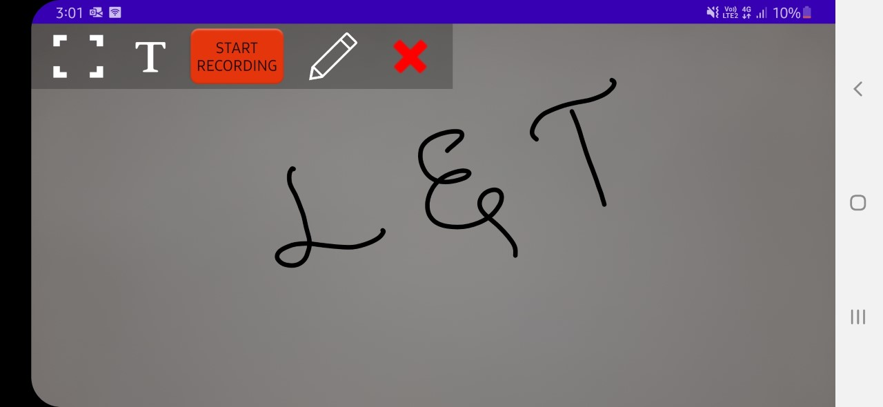

5.**Clear/Erase**: In order to clear the annotation, clear/Erase button is provided   
6. **Stop Recoding**: Once user done with the recording, user can stop recording by clicking on the stop recording

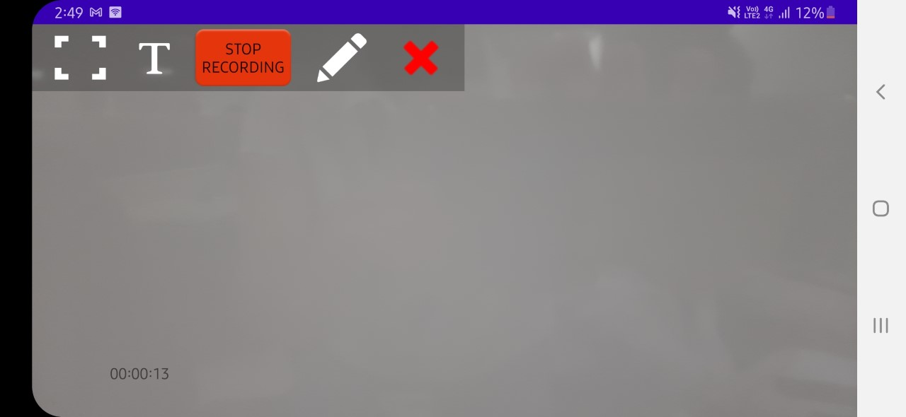

# Storage path:

After taking screenshot or screen recording, file will be stored in the respective folder

File path will be: Internal storage -> Camera Annotation

1.**Screen** **Recording**: All screen recording will be stored in this folder

2.**Snapshots**: All screenshots will be stored in this folder

3.**SnapshotsAnnotation**: Screenshot along with annotation will be stored in this folder

